

Kestral Anti-Slip Stair Nosings

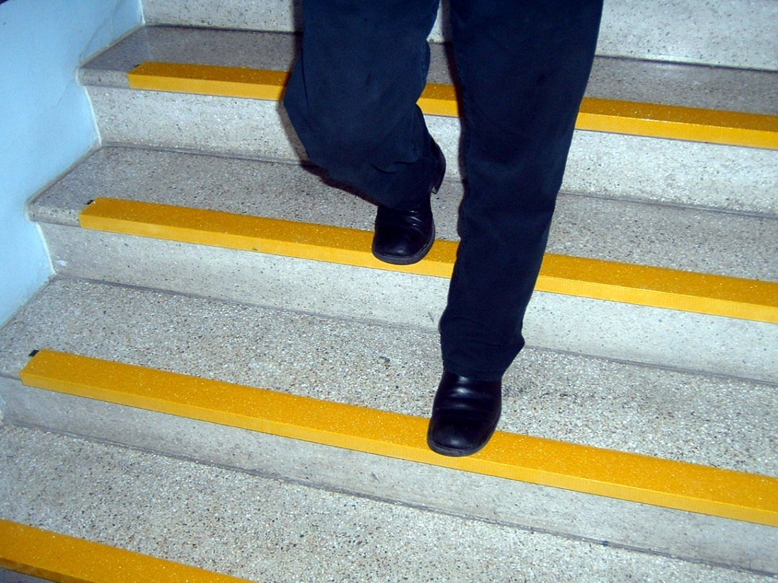

Kestral Stair Nosing provide a superior grip performance in extreme conditions, with excellent anti slip properties providing increased safety on steps and stairs and the high contrasting colour aids visability.

The grit is embedded into a specially pultruded GRP profile which is resistant to swelling, stretching or warping over a wide range of temperatures and physical stresses. Its strength means that it will help cover lightly chipped stair edges making them safer whilst protecting the stair edge itself to further costly damage.

* Anti-Slip
* Hard Wearing GRP Construction
* Installs Over Virtually Any Substrate
* High Contrast Colours
* Chamfered Edges
* High Performance Grit Formula
* DDA & Building Regulation Compliant
* Easy To Fit, Simply Screw and Glue to Wood, Steel, Concrete or Similar
* Cost Effective

