

Kestral Anti-Slip Flat Sheets

[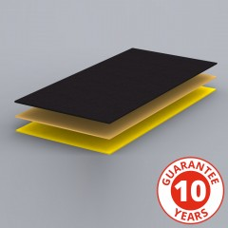](http://www.fibregrid.com/anti-slip-original-heavy-duty-flat-sheet-flooring.html)

The Kestral Anti-slip Flat Sheet range are high performance stair treads, landing covers and flat sheets, made form high quality GRP (Glass Reinforced Plastic), a combination of resins and reinforcing fibres.

SlipGrip Heavy Duty Flat Sheets comprise of a high quality composite of glass woven matting impregnated with isophthalic polyester resin. The energy absorption and flexibility of the product, ensures its long life, even in the busiest of environments.

The many and varied uses for these non slip flooring sheets are typically applied to most flat surfaces such as walkways, ramps, gangways, marina walkways, warehouse floors, disabled access ramps, stair landings, factory walkways and building entrances and other places where slipping is a possibility.

**Slip Resistant**Kestral Anti-slip Flat Sheets provide an excellent slip resistant and hard wearing surface.

**Corrosion Resistant**The Flat Sheets resist a wide range of chemicals and are perfectly suited for use even in the harshest of environments. Chemical resistance guides are available on request.

**Simple to install**Kestral Anti-slip Flat Sheets adhere to almost any surface such as concrete, steel or wood. It can be walked on straight away to minimise downtime.

* Anti-Slip
* Hard Wearing GRP Construction
* Installs Over Virtually Any Substrate
* High Contrast Colours
* High Performance Grit Formula
* DDA & Building Regulation Compliant
* Easy To Fit, Simply Screw and Glue to Wood, Steel, Concrete or Similar
* Cost Effective